**LINEAR REGRESSION FROM SCRATCH**

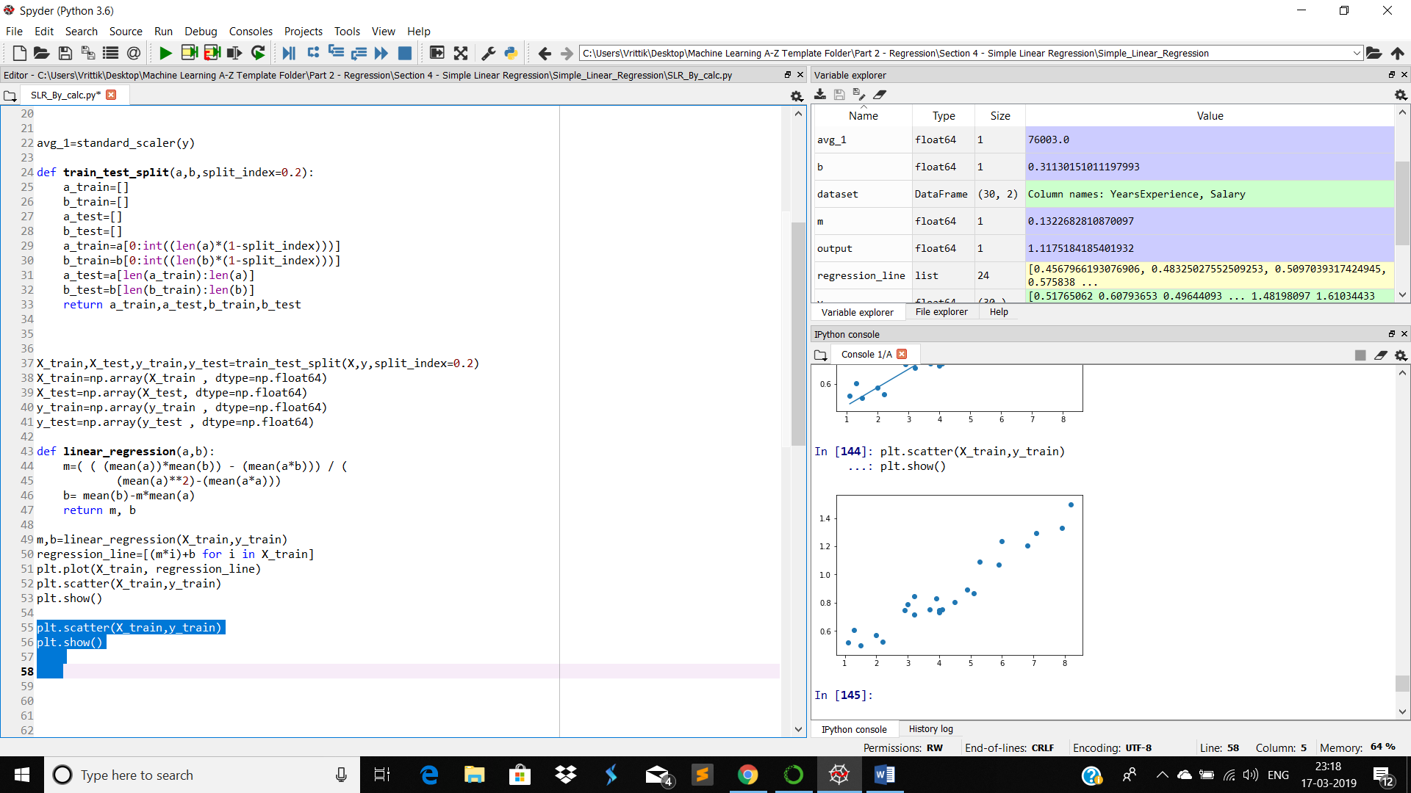

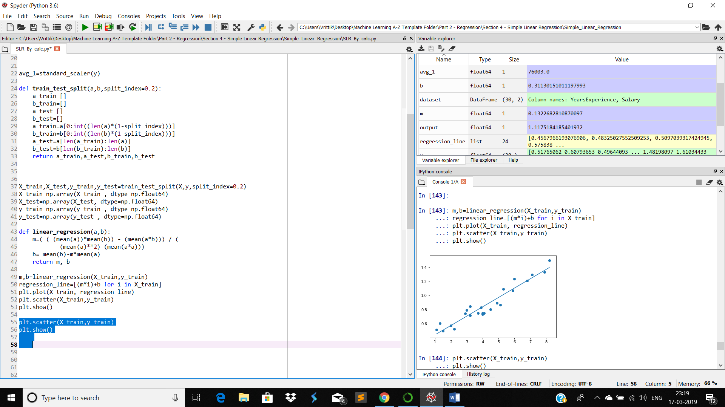

M= ( (mean(x_train)*mean(y_train))-mean(x*y)) / ( (mean(x)**2) -mean(x_train**2))

B=mean(y_train) – m*mean(x_train)

Prediction of a random input x

Y_pred=M*x + B

And here is how linear regression works.